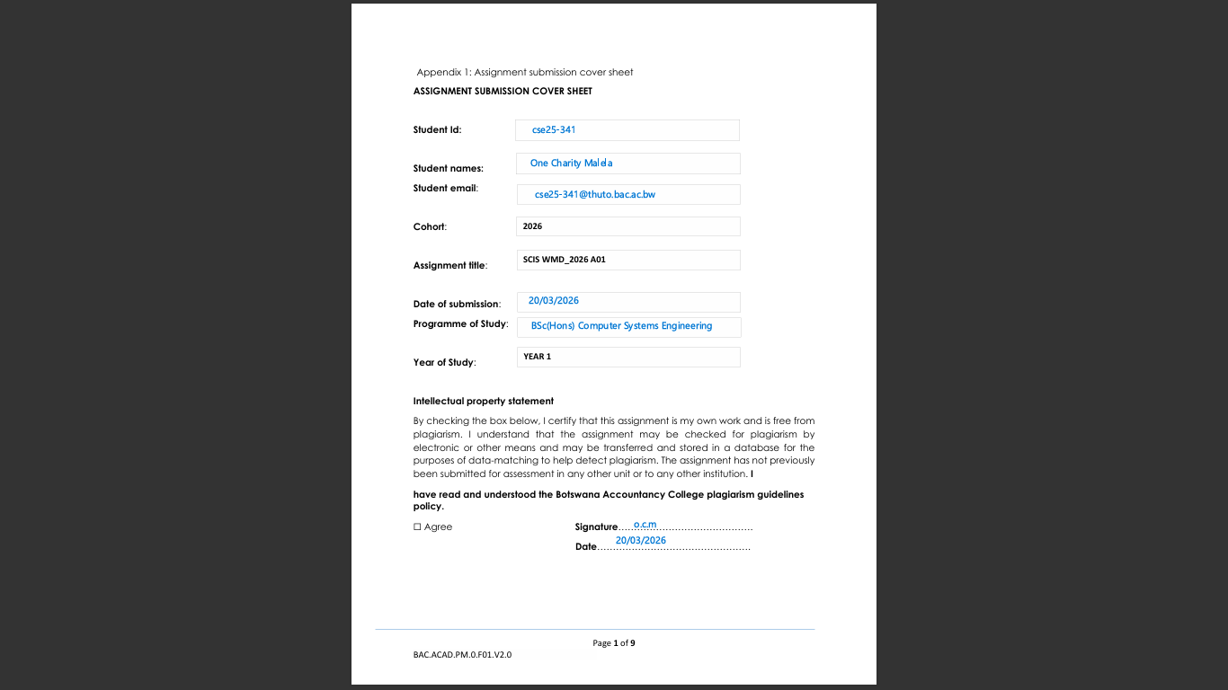

CREATING A WEBSITE FOR MALELA STYLES
PART A
1.Website Specification
- Website Objective & Goals

Objective:
The objective of Malela Styles is to create an online clothing platform where users can browse and purchase the latest trendy fashion items.

Goals
- To showcase trendy and affordable clothing items
- To increase brand awareness
- To allow customers to browse and purchase products
- To provide secure and easy online transactions

- Target Audience
The site targets males and females between the ages of 16 and 35, who are interested in fashion and online shopping and have basic technical skills allowing them to comfortably use smartphones, browse the internet and navigate online shopping platforms.

- Type of Website
Malela Styles is an e-commerce website, as it is designed to display, promote and sell clothing products online while allowing users to browse items, add them to a cart and make purchases.

2.Information Design & Taxonomy
The website will be structured in a clear and organized way to ensure easy navigation.

Site Map (Structure)
- Home
- Shop
- Men
- Women
- Accessories
- About us
- Contact
- Cart

Home Page

Feedback
Contact us
Gallery
Shop
About us
Email
Women
Comments
Images
Our story
Ratings
Phone number
Videos
Dresses, Tops, Jeans, Shoes
Vision
Why choose us
Reviews
Location
Features Styles
Men
T-shirts, Hoodies, Pants, Shoes

Accessories
Bags, Jewelry, Hats

Navigation Flow
Users will land on the Home Page, browse featured items, then move to the Shop page to view products. From there, they can select categories, view product details, add items to the cart and proceed to checkout.

Content Organization
Products will be categorized by type (e.g. clothing, accessories) and target group (men/ women). Each product will include images, prices and descriptions.

3.Page Template Design
The website will follow a consistent layout across all pages:
- Header: Logo (Malela Styles) and navigation menu
- Main Content Area: Displays products, images and text depending on the page
- Sidebar: Filters (price, category)
- Footer: Contact details, social media links, copyright

Wireframe Description
- Home page: Banner image and featured products
- Shop page: Grid layout of items
- Product page: Image, description, price and “Add to cart” button
- Contact page: Simple form with name, email, message

4.Technical Brief
The following technologies and tools will be used:
- HTML - to structure the website
- CSS - to style and design the layout
- JavaScript - for interactivity (e.g. cart functionality)
- VS Code - for coding
- GitHub - for version control and hosting
- Images/ Graphics Tools - Canva or online image sources
- Bootstrap: Responsive design and components
These tools are suitable because they are simple, effective and appropriate for building a functional e-commerce website.

5.Quality Assurance
Testing will be conducted to ensure the website works correctly:
- Browser Testing: Website tested on Chrome, Edge and Firefox
- Mobile Testing: Checked on smartphones to ensure responsiveness
- Functionality Testing:
- Links work correctly
- Buttons (Add to Cart) function properly
- Screenshots: Evidence of testing will be captured and included

6.Publishing & Promotion
The website will be hosted using GitHub Pages.
Hosting Process
- Create a repository on GitHub
- Upload all website files (including index.html)
- Enable GitHub Pages in repository settings
- Generate and share the live website link
Promotion Methods
- Social media marketing (Facebook, Tik-Tok, Instagram)
- Sharing the website link with peers
- Discounts and promotional offers

7.Future Developments
Potential improvements include
- Virtual try-on feature- Using augmented reality (AR), customers could “try on” clothes virtually to see how items might look on them before buying.
- More payment options- Introduce additional secure payment methods such as mobile money and digital wallets to make transactions easier for more users.
- Social media integration- Allowing users to login using their social media accounts and share outfits directly to platforms like Instagram or TikTok to promote the brand.

